Name: __________________________________________ Date:___________________
Compare these texts.
Comparing Characteristics of a Hero |  | 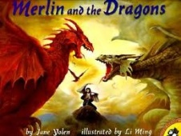
Bravery

Courage

Determination
Dedication
Endurance
Perseverance
Valor
Comparing Characteristics of a Hero
Selflessness
Sacrifice
Humility

